The Australian Food Industry
Make sure you can:
What are the sectors of the AFI + local examples

Plan and prepare a meal that reflects the sectors

Emerging Technologies in
Food Production -

Emerging Technologies in
Manufacturing

Emerging Technologies in
Packaging -

What is bio technology?

WHat are Genetically Modified foods - egs and definitions

Ecologically sustainable production methods such as Organic Farming - what is it - plus eg

Investigate ONE emerging technology in ONE sector of the AFI
(Selective Breeding AI at MCKays Dairy)

Positives/Benefits of this emerging technology | Risks / Negatives of Selective breeding

ASPECTS OF THE AUSTRALIAN FOOD INDUSTRY
McKays Dairy - Blackberry Road Bowraville NSW
Brief overview - describe the activities carried out
*Levels of operation

* Research and development

* Quality Assurance

* Consumer influences such as value added foods

INVESTIGATION OF ONE ORGANISATION
* Impact on the ENVIRONMENT, including :
Waste

Packaging practices

Production techniques

Transportation

Impact on the Economy - changes in employment and generation of profit

Impact on the SOCIETY - including lifestyle changes

Impact on INDIVIDUALS - Career opportunities and working conditions

Explain career opportunities and working conditions including gender issues within the AFI.
POLICY AND LEGISLATION
What role does advisory groups have in formulating policy and laws?

How do Govt policies (National, State and Local) impact on the Australian Food Industry? Include legislative requirements for labelling.
Identify significant pieces of legislation and explain their impact on the AFI.

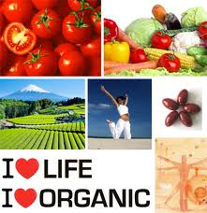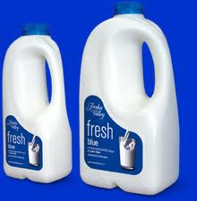

Summary Booklet
HSC FOOD TECHNOLOGY 2011
The Australian Food Industry

